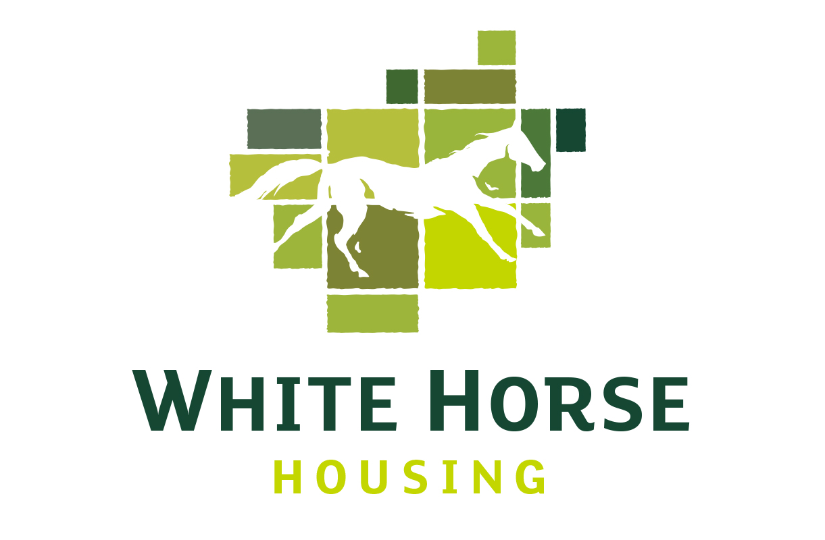

**Customer Services Advisor**

**(Full time – 37 hours per week)**

Salary £20,000 plus benefits

White Horse Housing Association owns and manages over 400 homes throughout Wiltshire, Swindon and Somerset and has plans to develop further new homes over the coming years. We prioritise a high level of service to our customers and have an excellent reputation as a smart, forward thinking organisation, which cares about its residents.

Do you value good service? Are you enthusiastic and efficient with a good telephone manner? If so, we would love to hear from you!

You would be the first point of contact for our residents, dealing with general enquiries, repair requests and satisfaction surveys. In addition, you would be responsible for administration tasks including word processing, post duties, scanning and data input.

Previous experience in a customer-facing role is important. Experience within a housing organisation preferred, but not essential.

Reporting directly to the Operations Manager, the successful candidate will be part of a small, friendly team dedicated to providing the highest quality service to our customers.

Benefits include: 25 days Annual Holiday and Contributory Pension Scheme.

Location: A mix of working from home and at our offices in Melksham, Wiltshire.

**Closing date:** 6th June 2022 **Interview Date:** 10th June 2022.

To request an application form and information pack please e-mail info@whitehorsehousing.co.uk

*We are committed to Equal Opportunities and welcome applications from all sections of the community.*