FOR SALE: Shared Ownership – Hook Hollow, Seend Cleeve
A passive house development of homes for local people
Date | 6th September 2023
Site Name | Hook Hollow, Seend Cleeve
Handover Date | To be confirmed.
Developer | White Horse Housing Association
Contact Details: | Belinda Eastland, Operations Director
 | Sarah Occleshaw, Housing Assistant
 | Email: info@whitehorsehousing.co.uk
 | Telephone: 01380 850916
Local Authority | Wiltshire
Region | Wiltshire
Scheme | Shared Ownership New Build
Number available | 3 available from 3
Property Value from | (subject to change as a new valuation is required 3 months prior to sale).  £335,000.00 (1 x 2 Bedroom house)  £375,000.00 (2 x 3 Bedroom house)
Shared Percent Example | 40%
Share Percent price | £134,000.00 (2 Bedroom house)  £150,000.00 (3 Bedroom house)
Monthly rent | £460.63 (2 Bedroom house)  £515.63 (3 Bedroom house)
Monthly Service Charge | £40.00 (2 Bedroom house)  £40.00 (3 Bedroom house)
Short Description | A Passive House Development of homes in a beautiful rural setting.
Property Features | Full passive house design with solar PV and High levels of insulation – low energy usage
 | Triple glazed windows and doors/heat recovery system
 | Dimplex Quantum RF HHR Storage Heaters
 | Air source pump water heater
 | Entrance hall leading to lounge with patio doors to the garden
 | Entrance hall leading to open plan kitchen/dining area
 | Fitted Kitchen – smart modern design built in over & hob
 | Smart modern bathroom plus ground floor WC
 | Fully carpeted, Vinyl flooring to bathroom, WC and Kitchen
 | Off road parking spaces
Current Energy Efficiency Rating | Not available
Current Environmental Impact (CO2) Rating | Not available

Description | This is a small development of 10 homes for local people and is being brought forward in partnership with Seend Community Land and Asset Trust. Set in a stunning rural location, Seend is a small village approximately 2 miles from the town of Melksham and 7 miles from the county town of Trowbridge. If you have a connection to Seend or surrounding parishes we would be pleased to hear from you.  The initial share available for purchase is between 10% to 75% subject to a financial assessment, further purchases of shares will be restricted to 80% in total to ensure these homes are available to local people in perpetuity. The example of costs given is based upon an initial purchase of 40%.
Additional Documents | These details do not constitute any part of an offer or contract. Any prospective purchaser must satisfy themselves by inspection or otherwise of the accuracy of the information displayed. With resales, none of the main services have been tested and you may wish to arrange your own independent survey before purchase.

Photos:

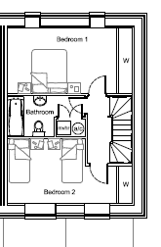
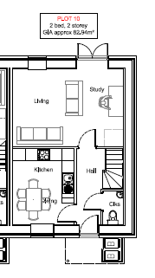
2-bedroom property – Plot 10
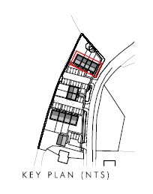

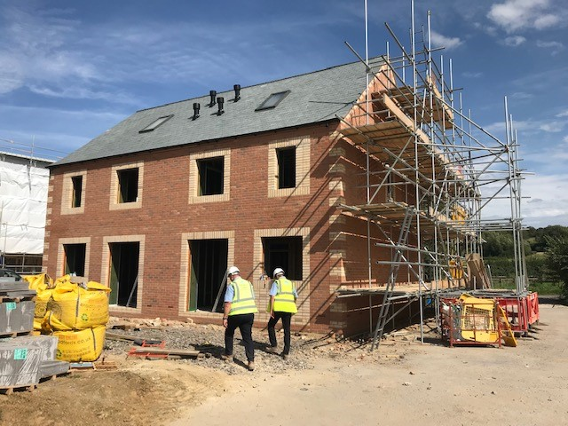
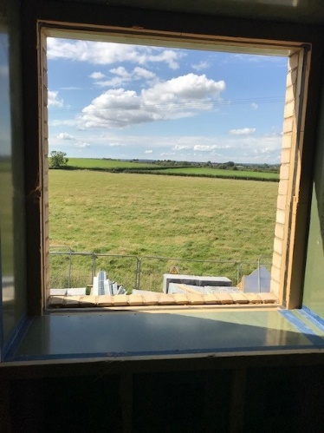
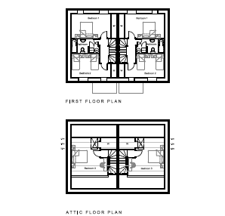
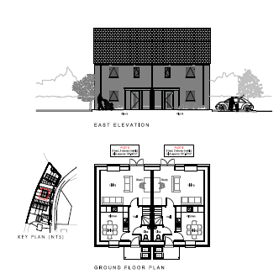
3-bedroom properties – Plots 5 & 6

