FOR SALE
Shared Ownership – The Cider Press, Ashton Keynes
Date | 26th January 2024
Site Name | The Cider Press, Ashton Keynes
Handover Date | March 2024
Developer | White Horse Housing Association
Contact Details: | Belinda Eastland, Operations Director
 | Sarah Occleshaw, Housing Assistant
 | Email: info@whitehorsehousing.co.uk
 | Telephone: 01380 850916
Local Authority | Wiltshire
Scheme | Shared Ownership New Build
Number available | 2 x 3 beds
Property Value from | £360,000.00 (3 Bedroom house)
Shared Percent Example | 40%
Share Percent price | £144,000.00 (3 Bedroom house)
Monthly rent | £495.00 (3 Bedroom house)
Monthly Service Charge | £21.00 Estimated (3 Bedroom house)
Short Description | 2 x 3 bed houses in a small, selected development in Ashton Keynes
Property Features | Large kitchen diner – smart and modern with fitted cooker hood, hob and oven.
 | Smart modern bathroom with shower over bath.
 | Ground floor cloakroom.
 | Dimplex Quantum Storage Heaters with Programmer/thermostats.
 | Solar PV on the roof to keep electricity bills down.
 | Fully carpeted, vinyl to kitchen, bathroom and GF WC.
Current Energy Efficiency Rating | Not available
Current Environmental Impact (CO2) Rating | Not available

Description | Fantastic location close to Cotswold Water Park. Lovely village with shop and pub.  Initial share purchases can be between 10% and 75% (example shown is 40%).  Staircasing to 100% is permissible.  Applicants with local connections to Ashton Keynes or surrounding area will be given preference subject to financial assessments.
Additional Documents | These details do not constitute any part of an offer or contract. Any prospective purchaser must satisfy themselves by inspection or otherwise of the accuracy of the information displayed. With resales, none of the main services have been tested and you may wish to arrange your own independent survey before purchase.

Photos:

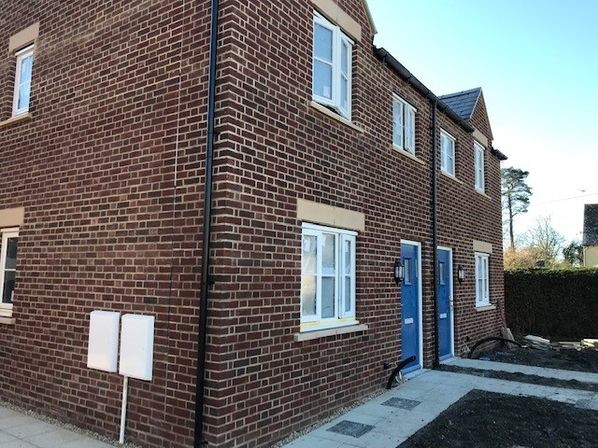
The Cider Press, Ashton Keynes

