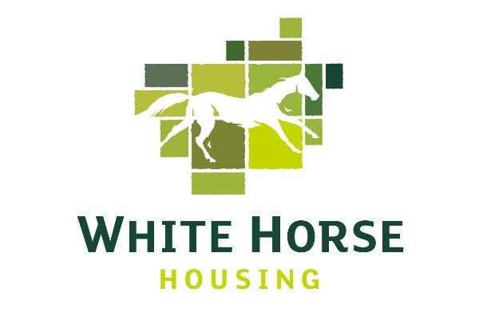

Policy Name | Policy 31 – Environmental Sustainability Policy Statement and Strategy
Author | Encredible (Consultancy), Chief Executive
Tozers Reviewed? – HR Policies only

Board Approval | November 2021

Environmental Sustainability Policy Statement

Our aim is:

“To be as environmentally sustainable as practicable, in balance with our corporate commitments of social and economic sustainability”.

We are committed to becoming a leader on environmental sustainability within the small housing association sector and adopt, where practical and affordable, innovative approaches that seek to continually raise standards and reduce carbon emissions: We will achieve this through:

- provision and management of our homes in a way that manages our energy, waste and water impacts, and supports sustainable procurement and biodiversity,
- continual improvement of our environmental performance,
- prevention of pollution, and
- compliance with our legal and national policy obligations.

This will be achieved through:

- an environmental sustainability strategy including objectives and targets,
- an environmental sustainability action plan,
- embedding environmental sustainability within our working practices, and
- measurement and reporting of our impact.

Steve Warran,
Chief Executive

Environmental Sustainability Strategy

INTRODUCTION

This is White Horse Housing Association’s (WHHA) Environmental Sustainability Strategy for 2021 to 2026, aligned with our Business Plan. It has been produced in response to the climate emergency.

Our main aim with this strategy is to be as environmentally sustainable as practicable, in balance with our corporate commitments of social and economic sustainability.

The following diagram illustrates what this means at WHHA in relation to our corporate mission “to be a leading provider of high quality affordable homes in the rural communities of Wiltshire and its surrounding areas”.
ENVIRONMENTAL

ECONOMIC

SOCIAL

Homes that promote biodiversity, health and wellbeing
Homes that are energy and water efficient with affordable utility bills
Homes that support WHHA’s financial security to provide more homes
SUSTAINABILITY

Affordable and sustainable homes for local people in need

BUSINESS DRIVERS

At WHHA, we believe that environmental sustainability is about more than our responsibility to ‘do the right thing’. We recognise the importance of environmental sustainability for:

Risk - meeting national and local policy and target requirements.

Return - providing affordable homes that reduce fuel bills and lead to fewer rent defaults.

Reputation - being an association of choice for customers, investors and local authorities.

ENERGY AND CARBON
Our objective is to reduce energy use and associated carbon emissions from the homes we provide, our office and our business mileage.

We will continue to:

- Build homes that seek to exceed existing standards of energy efficiency and prepare for the Future Homes Standard by learning from our exemplar developments.

We will consider:

- The measures required, and likely costs associated with, meeting the national EPC band C target and plan our approach within a revised Asset Management Strategy – by November 2021

- The options available to us to reduce our business mileage emissions, including increased electronic customer interactions and use of new technology – by April 2023

- Our use of office space and implement either space reduction or improved energy efficiency measures – by October 2023

WASTE
Our objective is to reduce the amount of waste produced and divert waste from landfill at the office, with our contractors and our residents.

We will continue to:

- Run a zero waste to landfill office.

- Support residents to recycle through integration of facilities into new build properties.

- Reduce fly tipping and increase recycling through estate initiatives.

- Require our new build contractors to reduce waste and manage waste responsibly.

We will consider:

- Requesting waste related KPIs and setting diversion from landfill targets for our repairs and ground maintenance contractors by April 2022.

WATER
Our objective is to minimise water consumption in the homes we provide and at our office.

We will continue to:

- Install water butts on new developments, where possible.

We will consider:

- A variety of water saving measures including those that reduce use or recover heat from hot water for installation on new build properties – by April 2023.

- Increased installation of water efficient fittings as standard on bathroom and kitchen replacements and/or void properties – by April 2022.

- Basic water saving measures for the office – by December 2021.

SUSTAINABLE PROCUREMENT
Our objective is to encourage our contractors towards environmental sustainability and procure sustainable goods where practical.

We will continue to:

- Assess the lifecycle impacts and costs of the goods we purchase.

- Include relevant environmental criteria within our PQQ process for contractors.

We will consider:

- Specification of minimum standards for environmental impact of materials and products in new development – by April 2022.

- Introduction of contract specific tender questions and the setting of contract KPIs relating to environmental sustainability – by April 2022.

BIODIVERSITY
Our objective is to conserve biodiversity on our developments and in the rural villages where we operate.

We will continue to:

- Implement high ecological standards on our new developments, including bird and bat box installation and native and wildlife friendly shrubs and trees.

- Manage our meadow areas and nature reserves to promote biodiversity.

We will consider:

- Introduction of tree management plans and increased meadow mowing practices – by April 2023.

- Appropriate measures to increase biodiversity on existing estates - by April 2024.

MONITORING AND REPORTING

The annual carbon, waste and water footprint for the organisation will be calculated and reported to the Board.

An additional, six monthly update will be provided to the Board on progress with this strategy and the Environmental Sustainability Action Plan.

Environmental sustainability performance will be reported in the Annual Review, the Annual Report to Tenants and included on our website.

Key Performance Indictors will include:

Organisational carbon footprint:

Carbon footprint at April 2021 = 14.26 tonnes
Carbon footprint at March 2026 = 12.83 tonnes (10% reduction)

Housing Stock carbon footprint

Carbon footprint at November 2021 = 1,350 tonnes
Carbon footprint at March 2026 = 1,282 tonnes (5% reduction)

Housing Stock Legal Compliance

All housing stock to reach an EPC rating of ‘C’ or above by 2030 (unless exempted)

