

Board member vacancies 2025

At White Horse Housing Association, we provide high quality, affordable and sustainable homes in rural communities across Wiltshire, Swindon and East Somerset. Founded in 1984, we currently own 460 homes across 57 villages. We manage and maintain our homes to a high standard and provide efficient, professional and responsive services to our customers.

Our board members come from a variety of backgrounds and bring a diverse range of skills, experience and knowledge to our discussions. They are passionate about maintaining and improving the sustainability of rural communities and providing strong strategic leadership.
We are interested in hearing from anyone with relevant experience in one or more of these areas:

- leadership and working as an effective team;
- direct knowledge of the needs and aspirations of the rural communities we serve;
- knowledge of the current operating environment for social landlords;
- effective communication skills.

We are particularly interested in hearing from candidates who have experience in organisational change and people management and in finance.

Although our board members are unpaid (except allowable expenses) the work is both rewarding and enjoyable. The board meets up to eight times each year.

If you are interested in being part of our exciting future, send your CV, along with a supporting letter, that includes your skills and experience and your reasons for applying for the position.

For an informal chat about becoming a board member, call Chief Executive Steve Warran on 01380 850916. For more information about us visit www.whitehorsehousing.co.uk or follow us on Facebook and LinkedIn.

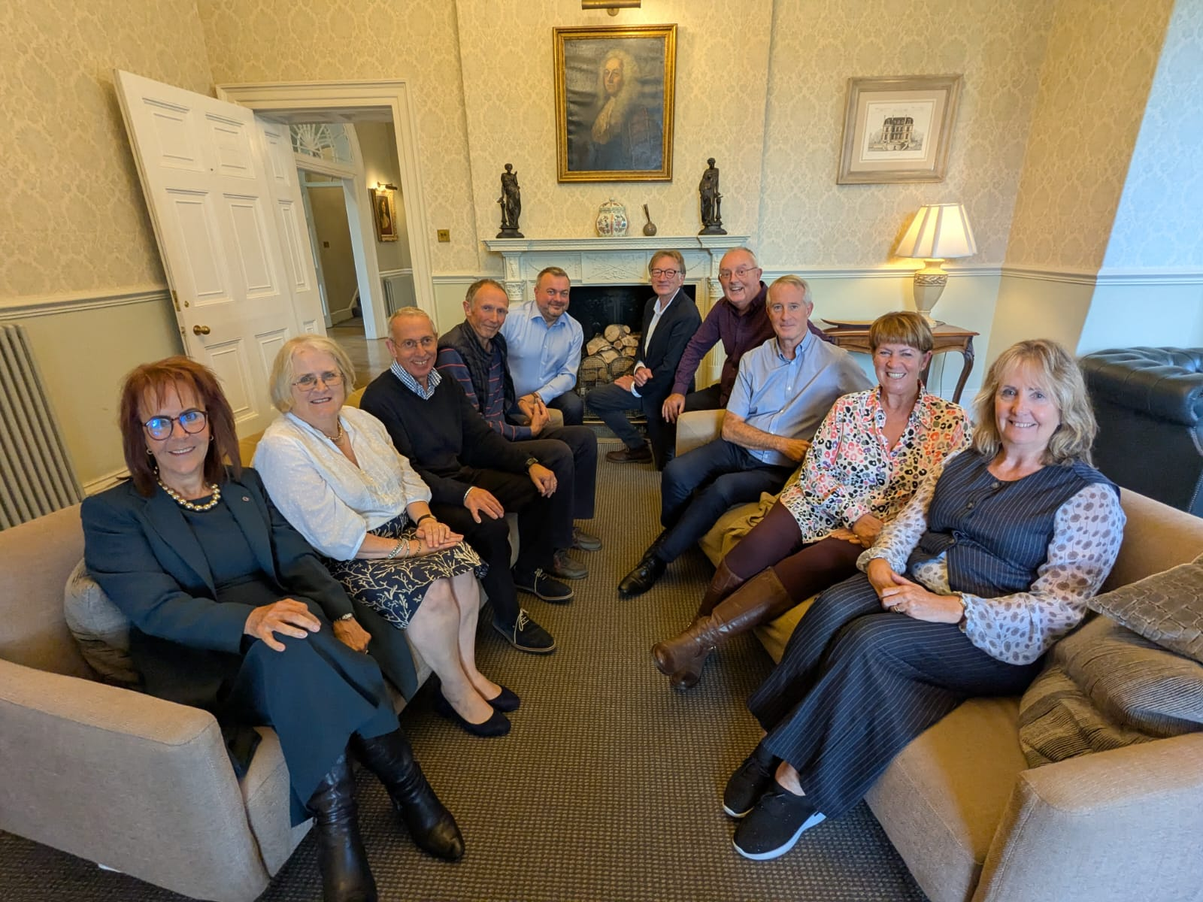

Board members and senior managers at a recent awayday

Board member job description

Introduction

- Board members are responsible for the overall governance and strategic direction of the association; developing and committing to its mission and objectives; and ensuring its continuing financial viability – all in accordance with the constitution, the law and regulatory requirements.
- Day to day management is the responsibility of the Chief Executive. This role profile is designed to guide board members in fulfilling their duties and responsibilities.

Principal duties as a board member

  - The principal duties of all board members are set out below:

- To exercise independent judgment and to act only in the interests of the association and not on behalf of any constituency or interest group.
- To act in accordance with the law and the constitution of the association and only exercise powers for the purpose for which they are conferred.
- To act in a way that enhances the success of the association.
- To exercise reasonable care, skill and diligence.
- To avoid a situation where there is or may be a direct or indirect interest that conflicts, or possibly may conflict, with the interests of the association.
- To ensure that no benefit is accepted from a third party conferred by reason of being a board member or of doing (or not doing) anything as a board member.
- To declare the nature and extent of any interest to the board or to a committee if in any way, directly or indirectly, interested in a proposed transaction or arrangement with the association.
- To have regard to any relevant advice provided by the Chief Executive and other advisers when reaching decisions.

- Main responsibilities as a board member

  - The main responsibilities of all board members are set out below:

- Strategic leadership:
- To help develop and share in the association’s mission.
- To uphold and demonstrate the association’s values and the principles for which it stands.
- To participate in the development of strategies and policies for approval by the board to guide the association’s work.
- To focus on the setting and monitoring of objectives, performance targets and benchmarks across all aspects of the business.
- To contribute to the evaluation of opportunities, threats and risks across the external environment and strengths and weaknesses in the internal environment.
- To keep up to date with sector issues.

- Good governance:
- To be focused on ensuring that the association is managed efficiently, effectively and in compliance with the requirements of the law, the constitution, regulation, adopted codes and best practice.
- To ensure the integrity of financial information presented to the board.
- To challenge the robustness of frameworks for financial planning, management of risk, internal controls and the safeguarding of assets.
- To comply with, and act within, the association’s policies, procedures and guidance as set and amended from time to time by the board or other authorised body.
- To fully participate in the work of the board and its committees; and participate as required in working groups, focus groups, or panels in support of the overall governance of the association.
- To uphold the Code of Conduct and the reputation of the association and not do anything which may bring discredit upon the association.
- To promptly declare any relevant interests, financial or non-financial, for entry in the register.
- To act as a role model for good governance practices and behaviours.

- Effective meetings and decision making:
- To prepare for meetings and other events by reading the reports, seeking clarification where necessary and when possible from report authors before meetings.
- To receive and consider reports prepared by employees, agents and advisers and question these to ensure that decisions are well founded.
- To regularly attend meetings of the board and its committees (if appointed); participate fully in discussions and share responsibility within the decision making process.
- To treat written information labelled as confidential, or oral information provided in confidence, as strictly confidential at all times unless otherwise authorised to release such information.
- To debate in a proper, respectful manner, addressing only matters in hand, keeping contributions relevant, not making speeches and avoiding operational detail.
- To contribute to, share responsibility for, and uphold the decisions of the board or committees irrespective of any individual position taken in debate or voting.
- To ensure all decisions are made in the best interests of the association.

- Performance, development, communication and relationships:
- To attend appropriate training and other events and represent the association as required.
- To participate openly and honestly in collective and individual appraisals, skills audits and succession planning.
- To work effectively with all employees, recognising the association’s duty of care as an employer and the Chief Executive’s responsibilities for management and supervision.
- To be open in communication and maintain good working relationships with all others involved in the governance and leadership of the association.
- To demonstrate proficiency in the use of information technology in conducting business with the association.
- To act as an ambassador for the association; networking and promoting the achievements and benefits of the association.
- To demonstrate commitment to equality and diversity.

Board member person specification

Introduction

Board members are appointed on the basis of the skills, knowledge and experience that the association needs to have amongst the membership of the board and its committees. They must also possess a number of core competencies and be able to make the necessary commitment to the role. All board members are encouraged to undertake training and other learning opportunities in order to expand their skills, knowledge and experience and to develop their competencies.

This person specification is designed to guide board members in fulfilling their duties and responsibilities as effectively as possible. It will also be used to support the appraisal of board member performance.

Skills, knowledge and experience

  - Each board member is expected to contribute strengths in at least one or more of the blocks of skills, knowledge and experience required on the board and its committees (see board Skills, Performance and Development Policy). Any gaps in skills, knowledge and experience will be a consideration when carrying out succession planning and recruiting new board members. The extent to which individuals have made effective use of their strengths in skills, knowledge and experience will be taken in to account as part of board member appraisals.

Core competencies

  - Core competencies are used to measure personal effectiveness in the ability to lead, inspire and add value to the governance of the association. The performance of board members will be assessed annually and will focus on the core competencies (and supporting effective behaviours) set out below:

- Strategic thinking and direction:
- Influences the development of the mission and objectives.
- Understands the difference between strategy and operations; delegates responsibility effectively to the Chief Executive and other employees.
- Is sensitive to the political, economic, social and technological external impacts upon the business.
- Anticipates and understands risks and consequences for the association at a strategic level.
- Identifies opportunities and brings forward new ideas for business strategy and organisational effectiveness.
- Encourages creativity, is open to new ways of working and able to adapt flexibly to change.

- Analysis and understanding:
- Assimilates and makes sense of complex data; evaluates options and understands different perspectives.
- Focuses on the key issues and makes them clear to others.
- Understands the sensitivities of key assumptions in business propositions.
- Satisfies themselves on the integrity of financial information and risk appraisal.
- Possesses confidence to provide challenge; asks questions appropriately and keeps to appropriate level of detail.
- Brings an original perspective to discussions.

- Decision making:
- Shows independent judgement and original thought.
- Signs up to the collective ownership of decisions once agreed irrespective of position taken in debate.
- Actively participates in decision making with objective analysis, reasoned and rational judgement of the issues in hand.
- Prepared to take difficult decisions and measured risks; is not easily deflected by obstacles or problems.
- Respects and is open to the views of others in discussions on key issues.
- Focused on the mission, objectives and priorities when making decisions.

- Communication and interpersonal skills:
- Communicates clearly and persuasively; expresses opinions, listens and takes account of the views of others.
- Builds and maintains good relationships based on personal credibility and integrity.
- Engages effectively with key stakeholders as an ‘ambassador’ for the association.
- Challenges without appearing aggressive; prepared to say what people may not want to hear.
- Expects constructive feedback; is aware of own strengths, weaknesses and motivations.
- Gets to know individuals and their aspirations.

- Team working and development:
- Supports a strong team spirit; able to work collaboratively.
- Works with senior management in productive working relationships built on mutual respect.
- Works as a part of the team and adds value to the work of the board.
- Demonstrates commitment to the board and its committees; is reliable and punctual and comes fully prepared.
- Supports others, praises achievements and celebrates success with the team.
- Open to learning and development, for self, employees, and the board.

- Organisational purpose and ethos:
- Committed to meeting the needs of people in housing need and other vulnerable people.
- Open to the views of customers in the development of strategy, policy, standards and service delivery.
- Supports the development of organisational culture built around the values.
- Committed to the recruitment and development of a skilled and competent workforce.
- Encourages partnership working with organisations that add value to the work of the association.
- Promotes and demonstrates leadership in relation to equality, diversity and inclusion.

- Commitment to the Role

  - board members are expected to have the capacity to be able to commit to fulfilling their duties and responsibilities as effectively as possible. As a guide, the following (equivalent days) commitment is expected:

- Attending one day of induction training in the first 3 months following appointment.
- After induction being able to commit around 12 days a year to the role to include:

  - Effectively preparing for, attending and participating in formal meetings of the board and committees if appointed (and potentially other panels, working groups and any special meetings called from time to time).
  - Attending the association’s AGM, away days and training activities.
  - Participating in ad hoc discussions and electronic communications between meetings with other board members and employees.
  - Preparing and participating in own appraisal.

